CALIFORNIA YOUNG READER MEDAL ORDER FORM
www.californiayoungreadermedal.org
The California Young Reader Medal Committee has the following
materials available to promote the California Young Reader Medal program.

Item Quantity Price Total
Stickers for Nominated Books (25) x __________ $5.00 _________________
Logo Seals for Winning Books (20) x __________ $5.00 _________________

Shipping _________________
Total _________________
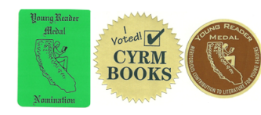
(“I Voted” stickers are no longer available.)

Shipping Costs
Subtotals Shipping
Up to $10.00 $2.95
$10.01 - $25.00 $3.95
$25.01 - $45.00 $5.95
$45.01 - $65.00 $7.95

Name of School or Library _______________________________________________________________
Street Address ________________________________________________________________________
City _______________________________________ State _________________ ZIP Code ___________
Email Address _________________________________________________________________________
VISA ____ MasterCard ____ American Express ____ Card #___________________________ CVC _____
Name on Card _________________________________________________ Expiration Date ____/____
Remittance must be included with each order. Purchase orders, checks, VISA, American Express or MasterCard are accepted. Send orders to:
California Reading Association
CYRM Committee Merchandise
19630 Allendale Ave • PO Box 2457
Saratoga CA 95070
Questions? - Email: cyrmmerchandise@gmail.com

